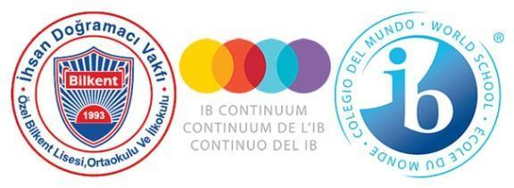

**Özel Bilkent Schools**

**ACADEMIC INTEGRITY POLICY**

**FOREWORD**

The Özel Bilkent Primary, Middle and High Schools wish to thank the students, parents, academic and administrative staff, who have contributed to the renewal and development of our school policies by participating in the process of formulating and recording our beliefs and procedures in the following policy documents: Child Protection Policy; Admissions Policy; Language Policy; Academic Honesty Policy; Assessment Policy; Inclusion and Special Educational Needs (SEN) Policy.

Our schools were established in 1994. Thanks to the support and feedback of our school community over the time since its foundation, we have witnessed strong growth in the numbers of parents wishing to offer their children an internationally minded education with us. The latest stage in our development was the authorization for the Middle Years Programme in 2018, which, by connecting the Diploma and Primary Years Programme, has ensured the consistent application of our curriculum philosophy across the three schools.

We welcome comments and constructive feedback on all our policies in order to contribute to further development and improvement in the delivery of our curriculum.

As a school community we are committed to working together to ensure that these policies are applied effectively, kept up to date, and adhered to within a positive mindset to the benefit of the whole school community.

This policy was last revised in May 2025. It will be revisited at the beginning of each academic year, or as needed in coordination with programme coordinators, teachers, administrators, parents and students.

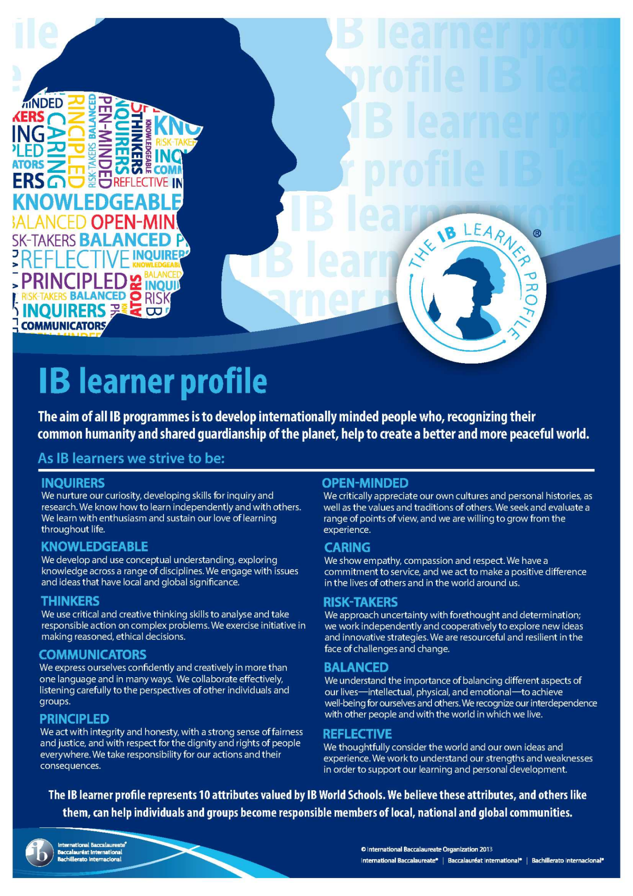

International Baccalaureate Learner Profile, © International Baccalaureate, Published July 2007

**CONTENTS**

1. Purposes of the Academic Integrity Policy 5
2. Implementing the Learner Profile to Maintain a Culture of Academic Integrity 6
3. Rights and Responsibilities in Matters of Academic Integrity 6
   1. Students 7

## 3.1.1 Academic honesty in examinations 7

## 3.1.2 Academic honesty in research and assignments 7

* 1. Teachers 8

3.2.1 List of duties 8

3.2.2 Responsibilities regarding accepting, maintaining, modeling and 8 internalizing the principles of academic integrity.

3.3 The Library and Librarians 9

* 1. Parents and Legal Guardians 9

#### 3.4 School Administration and Leadership Team 10

4. Rewarding Skills That Promote Academic Integrity 10

# 5. Actions/Sanctions in Case of Violation of the Policy 10

5.1 Definitions, Action and Sanctions for Maintaining Academic Integrity 11

5.1.1. Cheating 11

5.1.1.1. Cheating during internally assessed school exams 11

5.1.1.2. Cheating in externally assessed IB exams 11

5.1.1.3 Using prohibited materials during an exam 12

5.1.2. Plagiarism 12 5.1.3. Not complying with citation conventions 13 5.1.4 Abusing Responsibility in Collaborative Assignments 13 5.1.5. Disruptive behavior during internal and/or external exams 13

5.1.6. Taking the exam in someone else's place 14

Resources 15

# Forward

The digital age has eliminated many barriers to communication and brought the world's citizens closer together. With this era, the forms of information sources have diversified, and faster access to information has become possible by eliminating the boundaries of place, time and space. The increase in the richness of access to information sources has created the need to combat all kinds of misinformation and disinformation. In this age where content is freely produced and published, the ability to decide, access, select, use and synthesize accurate, valid and reliable information has gained importance. This development calls for a renewed emphasis on the importance of upholding the principles of academic integrity.

“Academic integrity is a guiding principle in education and a choice to act in a responsible way whereby others can have trust in us as individuals. It is the foundation for ethical decision-making and behaviour in the production of legitimate, authentic and honest scholarly work.” (IB Academic Integrity Policy 3*)*. It is the use of information within the framework of ethical and legal rules. With AI and increased access to information, it is now even more important to teach students the moral issues they need to consider in all their print and digital work. This written policy on "academic integrity" is an honest, fair and principled policy, respecting the legally defined rights of students studying in both the International Baccalaureate Program and the National Curriculum, teachers and school community members, including their parents, and owners of works such as writers, commentators and composers. They are expected to behave accordingly.

With this written policy, we expect students and individuals doing academic studies to apply legal and ethical rules and to act by fulfilling the basic principles of academic integrity such as honesty, equality, respect, courage and responsibility in every aspect of their lives. Our goal is to ensure that the philosophy of academic integrity is internalized in the school community. In this context, in the studies to be carried out in the school community (exhibition booklets, community project, personal project, graduation thesis, internal evaluation studies, reports, homework, performance work and project, e-portfolio tasks), they must comply with the ethical and legal rules regarding copyright and plagiarism issues and within this framework, they must work within the framework of fair use principles. They are expected to write in academic language at international standards.

1. **Purposes of the Academic Integrity Policy**

“Fostering an academic integrity culture, and a personal positive attitude towards it, requires the design of a school strategy that combines policies and good academic practice, while understanding the fundamental dimension it has in the authentic construction of meaning and learning in all IB programmes.” (9) Our School’s Academic Integrity Policy informs all members of the school community, teachers and students in International Baccalaureate and Ministry of National Education programs, about the rules they must follow and their responsibilities when sharing written and oral work. It was developed to create standards compatible with the IB Academic Integrity Policy in the implementation of the process. The policy defines and explains behavior consistent with academic integrity, unacceptable behavior, and the actions and process to be implemented when misconduct is detected.

The implementation and maintenance of this policy promotes understanding of academic honesty and responsible use of resources within the Özel Bilkent Schools community. By fostering respect for intellectual property and encouraging its protection without relying on sanctions, stakeholders in the school community embrace their responsibility to guide and support one another throughout this process.

The overall aim of the policy is to encourage all members of the school community, including parents and other stakeholders, to act with honesty and integrity, a laudable sense of justice and respect for individual rights, in particular to uphold these principles despite external pressures.

# Implementing the Learner Profile to Maintain a Culture of Academic Integrity

* Students know that cheating during examinations and tests is stealing the work of others. Being **caring** prevents cheating and the opportunity for others to cheat.
* Students are aware that being **principled** entails maintaining discipline during examinations and tests as well as following invigilator’s instructions.
* Students do their duty and complete their tasks themselves without the assistance of others. If necessary, they will **take risks** to complete their tasks successfully.
* While working in groups, students will work efficiently to complete their tasks. They will be **caring** and **balanced** while interacting with other group members, communicate their ideas with **open – mindedness** and **respect** the perspective of others.
* While doing research, students will be impartial and objective as well as **reflective**. Students will also remember the importance of asking questions and **inquiring** into the subject.
* While doing homework, research or working on a project, the students will make reasonable and conscious decisions using critical and creative **thinking** skills.
* Students **respect** the work of others and avoid copying the ideas and products of others to show them as their own in homework or projects. To prevent this, they use in-text citation and summarization techniques in accordance with MLA 9 (Modern Language Association) rules. At the end of the text, they provide detailed bibliography.
* Students exercise being **principled** by using MLA 9 to make a reference list of various printed and electronic resources they have used in their work.
* Students fulfil their responsibilities of being a responsible, digital citizen while doing their own work and act in a **caring** manner while citing various sources.
* Students **respect** copyright law and avoid using pirate copies.
* Students are knowledgeable while using various technologies and avoid intellectual theft and/ or copying information.
* Students are **knowledgeable** when using the technologies offered by the school. They question sources while scanning for information necessary for their research. They choose print and digital sources that contain valid and reliable information. For this purpose, they use databases subscribed by Bilkent University Library.
* While using artificial intelligence applications (ChatGPT, Easybib, Citation Machine etc.,) students are **principled, knowledgeable and caring.** They question the accuracy of the information They cite quotations from the applications they use in the text, and indicate the applications in the bibliography.
* Students are **knowledgeable** about penalties that may apply if they do not comply with citation requirements.
* While using local networks and internet both at home and school, students exercise the attributes of **caring** and **principled**, especially while using social media. They avoid unethical behaviour of posting derogatory information regarding persons or institutions, viewing or sharing visual content that may have inappropriate, disturbing or derogatory content.

1. **Rights and Responsibilities in Matters of Academic Integrity**

“Academic integrity is everyone’s responsibility. It must be part of the teaching and learning process and an aspiration of the entire school community.” (IB Academic Integrity Policy)

**3.1 Students**

Academic integrity is the balance of students’ rights to fair assessment, access to resources, and intellectual freedom and their responsibilities to produce authentic work, respect intellectual property, and uphold ethical standards. All students, when considering matters or practices concerning ‘Academic Integrity’ have the right to be:

* treated with decency as individuals;
* respected;
* heard;
* treated equally, fairly, and impartially;
* provided with an opportunity to explain their perspective;
* judged based on clear evidence;
* given a clear decision;
* treated according to the rules and regulations laid down in this document.

Students are also responsible for accepting, maintaining and internalizing the principles of academic honesty.

## 3.1.1 Academic honesty in examinations

All students should;

* respect the classroom environment to ensure exam security,
* adhere to the requirements announced by invigilators/proctors,
* not collude on questions in individual exams and assessment,
* not copy, duplicate or transfer others answers to their own exam paper,
* not use materials that are announced as prohibited during an exam,
* not communicate with others in any way which undermines the fairness of an exam.

## 3.1.2 Academic honesty in research and assignments

All students must act ethically in all the application and writing of research, projects or studies. They should

* acknowledge sources borrowed from the intellectual property of others,
* fully and completely cite all the sources they use in their research, projects or studies, using the technique of quoting and summarizing within the text and in the bibliography at the end of the text,
* mention any artificial intelligence applications they use in their research, projects or studies, in the bibliography at the end of the text, using citation and summarization techniques within the text,
* write their research, projects or studies, including any tables and figures (graphs, photographs, pictures, screenshots, maps, etc.) in accordance with MLA 9 standards,
* use written and visual materials appropriately in law with the laws of intellectual property laws; not have duplicated work completed by another person and submitted as their own.

**3.2 Teachers**

**3.2.1 List of duties**

Teachers have an important duty to;

* inform students about the Academic Integrity Policy and promote its use among students,
* teach and support academic writing skills (quoting, direct quoting, summarizing, table and figure representation, footnoting, preparing works cited and bibliography pages and appendices), as well as citation tools that can be used to help build academic integrity habits in accordance with age/grade levels,
* teach students about the importance of diversity, multiple perspectives, originality and impartiality in accessing information
* show students how they can benefit from audiovisual, digital resources and databases
* help teach students to use MLA and familiarize them with different citation styles (Chicago, APA, Harvard) and require students to use MLA in all formal assignments
* enable students to question and evaluate the reliability of the information they find on the internet
* ensure that students use their information literacy skills and the MLA study guide (in the High School) and the MLA referencing table in the Primary and Middle Schools when preparing any work for submission
* prepare evaluation criteria along with relevant marking rubrics which support academic integrity for all assignments/projects which include research/referencing.

**3.2.2 Responsibilities regarding accepting, maintaining, modeling and internalizing the principles of academic integrity.**

Teachers also have responsibilities regarding accepting, maintaining, modeling and internalizing the principles of academic integrity themselves. To this end, teachers should;

* internalize and support the Academic Integrity Policy,
* have an impartial attitude towards the work of various students maintaining the principle of fairness for all,
* arrange the exam environment with regard to the Academic Integrity and Exam Procedures of the school,
* use Modern Language Association (MLA 9) to reference the sources they share with the students,
* avoid and prevent the use of pirate copies,
* take ethical values into consideration if AI is used in the preparation of their course contents,
* use plagiarism or similarity checking tools to check the originality/AI generated content of student work (assignments, presentations, projects, bibliography).

Should a teacher suspect a violation of the Academic Integrity Policy by a student, the teacher will make their case, and provide concrete evidence of the violation if possible, and take action using required procedures.

#### 

#### 3.3 The Library and Librarians

The school believes that the library is an essential hub that provides various types of print and electronic resources necessary for students to adopt and maintain the principles of academic integrity. The librarian encourages the school community to utilize the library.

The aim of Ozel Bilkent School libraries is to;

* provide access to all information resources through an account and/or library card.
* ensure that the school community benefits from technological developments,
* support and improve students' existing reading and library usage habits,

In our school libraries, librarians teach our students information literacy skills that will enable them to become lifelong learners. The librarian;

* creates a reading culture by instilling reading habits in students,
* enhances students’ reading and writing skills,
* teaches research methods and techniques,
* informs students about relevant concepts such as academic integrity, copyright, plagiarism and fair use,
* informs students about our library and university library resources and services in order to maximize the effective use of library resources,
* teaches students how to conduct a literature review for their projects, to access various reliable information sources (e.g. printed books, journals, theses, e-books in databases, e-thesis, e-journal, e-conference proceedings, etc.) available in the databases and to select the resources they need,
* shows students the importance of using databases instead of the internet by teaching them to question the accuracy and reliability of sources on the internet,
* equips students with library literacy skills related to research methods necessary for their university study,
* develops students’ academic writing skills,
* teaches international standards (like MLA 9 rules) for in-text citation, summarizing, tables and figures representation, and writing complete and accurate references at the end of the text.

#### 3.4 Parents and Legal Guardians

It is the parent/legal guardian’s job to;

* internalize and support the “Academic Honesty Policy” presented at the start of each academic year during introductory meetings.
* support their children’s understanding of IB and school policies, procedures and subject guidelines by discussing and being role models for academic integrity.
* understand academic misconduct, discuss it with their children, and cooperate with the school in the case of any violations.
* consider ongoing effort and student development while evaluating the development of their children and they are aware of the fact that grades are not the only measure of success.
* be aware that their children are responsible for the completion of tasks/homework assigned by the school, and abstain from giving or obtaining undue and/or unauthorized assistance in the completion of their childrens’ work.
* avoid and prevent the used pirated copies.
* be informed about the use of artificial intelligence by the school.

#### 3.5 School Administration and Leadership Team

It is the responsibility of the school administration and Leadership Teams to;

* ensure that the “Academic Integrity Policy”, prepared within the framework of IB expectations, is accessible to all the members of the school community.
* ensure that all school and IB policies are applied fairly and consistently.
* encourage the internalization of the Academic Integrity Policy by organizing internal training for all members of the school community.
* inform students about the "Academic Integrity Policy" at all levels and have them sign "Academic Integrity Forms" for all IB projects and assessments.
* ensure compliance with secure storage of confidential IB material policy and the conduct of IB examination.
* follow procedures in the case of policy violation and decide on appropriate penalties.
* avoid and prevent the use of pirated copies.

1. **Rewarding Skills That Promote Academic Integrity**

Rewarding good practice recognizes the positive impact of motivation on student behavior. Exemplary students who exhibit appropriate behavior and are recognized and seen as successful give positive encouragement to other students to act similarly. The rewarded behavior may be academic and behavioral, or it may be related to achievement in arts or sports. Students selected by the Honor Award Committee and who meet the criteria and requirements of the committee are rewarded. The committee decides how many students will be selected for an award and the type of award to be given. More than one award may be given to a student.

1. **Actions/Sanctions in Case of Violation of the Policy**

The utmost importance is given to students at Bilkent Private Schools acting in accordance with the provisions of the "Reward and Discipline" regulation published by the Ministry of Education. Students must embrace and implement these requirements as well as to comply with the IB's external examination and internal assessment regulations.

Students must conduct themselves appropriately during examinations and oral presentations, when writing assignments, or when completing individual or group projects. Any form of cheating, including plagiarism, fraud, improper use of the intellectual property of others or encouraging others to do so, is expressly prohibited in the code of conduct for academic integrity. Rigorous ethical standards of behaviour with respect to academic integrity are a must for both the Turkish Ministry of Education and the International Baccalaureate. Both teachers and students must be aware of copyright rules and regulations and comply with intellectual property laws. The following rules, procedures and sanctions are applied in our schools for ensuring compliance with the academic integrity policy. In every case where Academic Integrity is violated, parents are informed expeditiously of the incident having taken place and, once taken, the decisions about any actions or sanctions are also communicated to the parents.

## 

## 5.1 Definitions, Action and Sanctions for Maintaining Academic Integrity

The school determines the limits of behavior contrary to academic integrity in alignment with both the International Baccalaureate and the Turkish Ministry of Education and clearly states the sanctions in case of violation. In this section, behaviors that violate academic integrity; Cheating, plagiarism, non-compliance with citing traditions, abusing responsibility in joint assignments, disrupting the exam order, taking the exam in someone else's place and using prohibited materials during the exam are defined and information is given about the procedures and sanctions to be applied in these cases.

**5.1.1 Cheating**

Copying is defined as “the illegal use of the ideas, materials or intellectual property of others, with or without their permission, and presenting it as one's own” (IB 2009).

**5.1.1.1 Cheating during internally assessed school exams**

If a student is caught or suspected of cheating during an internal exam, the paper is taken away and an incident report, along with any evidence, is submitted to the Administration. These documents are then forwarded to the disciplinary committee for review. If corroborated, the student will receive an official written warning from the disciplinary committee and the exam grade will be counted as “0”.

**5.1.1.2 Cheating in externally assessed IB exams**

If a student is caught cheating during an external IB exam, the paper is taken away and an incident report, along with any evidence, is submitted to Administration. The disciplinary committee issues a formal written warning. Since the exam is evaluated externally, the relevant IB Coordinator is informed. The Coordinator then informs the IB center about the facts surrounding the incident and recommends canceling the student's exam. Following IB approval, the student is notified that his/her exam has been cancelled. If the exam in question forms part of the student's IB Diploma Final Assessment, the student will automatically fail the Diploma program and will be barred from taking any future IB Diploma exams.

**5.1.1.3 Using prohibited materials during an exam**

Some exams allow the use of materials/tools such as calculators, books or notes, while other exams may prohibit their use. Using prohibited materials during an exam is defined as entering the exam room with clearly prohibited materials/tools such as calculators, mobile phones, and cheat sheets etc. Using prohibited or illegal materials/tools such as calculators or mobile phones during the exam is considered equivalent to cheating during the exam. When these situations are encountered, the procedures described above for "Cheating" are applied.

**5.1.2 Plagiarism**

Plagiarism is defined as “A member of the school community using all or part of another person’s work and submitting this work as their own knowingly and with intention to deceive” (IB 2009). This includes having someone else do one's work, with or without payment, and presenting that work as original, or presenting as one's own a work that has been copied in its entirety from an external source without acknowledging the source.

If a teacher or other employee of the school suspects plagiarism, the teacher confronts the student with evidence and addresses the issue through positive counseling as the first option. If the evidence that plagiarism has occurred is clear, the teacher may deduct points from the work or give the work a "0", depending on the severity of the plagiarism incident. The teacher also informs the Head of Department. The Department Head writes a note to the Student Affairs officer and the Administration, informing them of the situation and the subsequent action taken.

If there is work to be submitted to the IB as part of the overall IB assessment, this may be IB-moderated work marked by the teacher, or work directly assessed by the IB. If plagiarism is suspected before the work is officially presented, the teacher is authorized to deal with the issue in consultation with the IB Coordinator. The student may be asked to defend their work in front of the teacher and the IB Coordinator. If evidence of plagiarism is found, the teacher and the IB Coordinator may decide as follows:

1. Allowing the student to submit new work done by him/her under their supervision; however, the student may receive a lower grade due to the first incident of plagiarism.
2. To withdraw the student from the IB May Exams if a previously sanctioned case of plagiarism is repeated. In this case, the student will not receive a full IB Diploma or Certificate.

If a piece of work has been submitted to the IB for formal evaluation and plagiarism is detected after the work has been submitted, the school notifies the IB and IB procedures are applied. If the work to be assessed has not yet been submitted, the school may decide to withdraw the candidate from the IB May examinations.

If the IB detects and verifies evidence of plagiarism, it contacts the IB Coordinator and requests a signed “Academic Integrity” form confirming that the student acknowledged their work was 100% completed by them and complies with the rules of academic integrity. The IB reserves the right to withdraw the student from the program or annul the subject in which plagiarism took place. The IB may also require all IB students' work to be uploaded to the IB Information System to check for further cases of plagiarism. In addition, the IB reserves the right to visit the school without prior notice to check whether academic integrity procedures, student work and examination procedures comply with IB regulations.

**5.1.3 Not Complying with Citation Conventions**

Quoting without attribution is defined as “borrowing ideas, information or words from a source and not referencing their origin or presenting them as their own work, or not referencing the source correctly in references/bibliography page” (IB 2009).

Necessary information about the content and format of citation methods such as quoting is given in detail in the "MLA Study Guide" of Ozel Bilkent Schools, and is also explained to students by the librarian and teacher within the scope of regular support given to the curriculum. Procedure for misuse of attribution conventions will be applied according to the rules for plagiarism described above in section 5.2.

**5.1.4 Abusing Responsibility in Collaborative Assignments**

Abuse of responsibility is defined as “using a part or the whole of another student’s or group of students’ work without having taken an equal part in the production of the assignment and submitting it as though they were full contributors to the work, and endangering the quality of the assessed outcome” (IB 2009). This also includes taking advantage of a student's talent to gain more credit for work to which he or she has not fully contributed.

When abuse is suspected or one member of the group makes a formal complaint against another, the students involved are called to a meeting with the teacher, Vice Principal or IB Coordinator. Based on the evidence presented, a decision is made and students may be asked to complete new work under the supervision of the teacher. The abusive student may be offered different accommodations and the abusive student may be given a “0”. However, if both students are complicit in abuse, both students may be given a "0", at the discretion of the committee established for this purpose.

After the IB Coordinator and School Administration are informed of the incident, the student gives an oral and written statement. If it is certain that the work is not original and there is evidence showing this, a letter is written explaining the reasons for the decision and the student's work is canceled or gets a "0".

**5.1.5 Disruptive behavior during internal and/or external exams:**

Disrupting the exam order is defined as not respecting the secure nature of the exam or disrupting the correct implementation of an exam. Academic integrity requires respecting students' right to demonstrate the full potential of others during a formal evaluation.

The student is given a verbal warning for disruptive behavior. If disruptive behavior continues, the student will be removed from the exam room. The invigilator informs the school administration about the incident and the student continues the exam under supervision in another room. The teacher writes a report and submits it to the administration who reviews the incident and decides on the steps to be taken. If the behavior is considered a serious breach of school rules, the Disciplinary Committee will take over the incident and impose appropriate sanctions.

**5.1.6 Taking the exam in someone else's place**

Taking an exam in someone else's place is defined as "having another person who is not the examinee take an exam in the examinee’s stead with a view to cheating" (IB 2009). Due to the small population of our school, the probability of such an incident occurring is very slim, yet if it does occur, cheating procedures will be implemented. The disciplinary committee initiates a legal review process and appropriate sanctions are applied. The student's exam is canceled and the student is given a grade of "0". In the case of an external IB examination, the IB Coordinator informs the IB about the incident and the necessary procedures are followed which may result in the student’s not receiving an IB Diploma.

# RESOURCES

*Academic Integrity.* International Baccalaureate Organization, 2019. [www.ibo.org/](http://www.ibo.org/)content assets/76d2b6d4731f44ff800d0d06d371a892/academic-integrity-policy-english.pdf. Accessed 21 October 2023.

“Ministry of National Education Secondary Education Institutions Regulation.” *Ministry of Education*. September 8, 2023. [www.mevzuat.gov.tr/File/GeneratePdf?mevzuatNo=18812&mevzuatTur=KurumVeKurulusYonetmeligi &mevzuatTertip=5](http://www.mevzuat.gov.tr/%20File/GeneratePdf?mevzuatNo=18812&mevzuatTur=KurumVeKurulusYonetmeligi&mevzuatTertip=5). Accessed 21 October 2023.

*MLA Handbook.* 9th ed. The Modern Language Association of America, 2021.