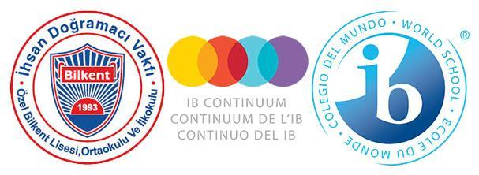

**Özel Bilkent Schools**

**ADMISSIONS POLICY**

**FOREWORD**

The Özel Bilkent Primary, Middle and High Schools wish to thank the students, parents, academic and administrative staff, who have contributed to the renewal and development of our school policies by participating in the process of formulating and recording our beliefs and procedures in the following policy documents: Child Protection Policy; Admissions Policy; Language Policy; Academic Honesty Policy; Assessment Policy; Inclusion and Special Educational Needs (SEN) Policy.

Our schools were established in 1994. Thanks to the support and feedback of our school community over the time since its foundation, we have witnessed strong growth in the numbers of parents wishing to offer their children an internationally minded education with us. The latest stage in our development was the authorisation for the Middle Years Programme in 2018, which, by connecting the Diploma and Primary Years Programme, has ensured the consistent application of our curriculum philosophy across the three schools.

We welcome comments and constructive feedback on all our policies in order to contribute to further development and improvement in the delivery of our curriculum.

As a school community we are committed to working together to ensure that these policies are applied effectively, kept up to date, and adhered to within a positive mindset to the benefit of the whole school community.

This policy was last revised in May 2025. It will be revisited at the beginning of each academic year, or as needed in coordination with programme coordinators, teachers, administrators, parents and students.

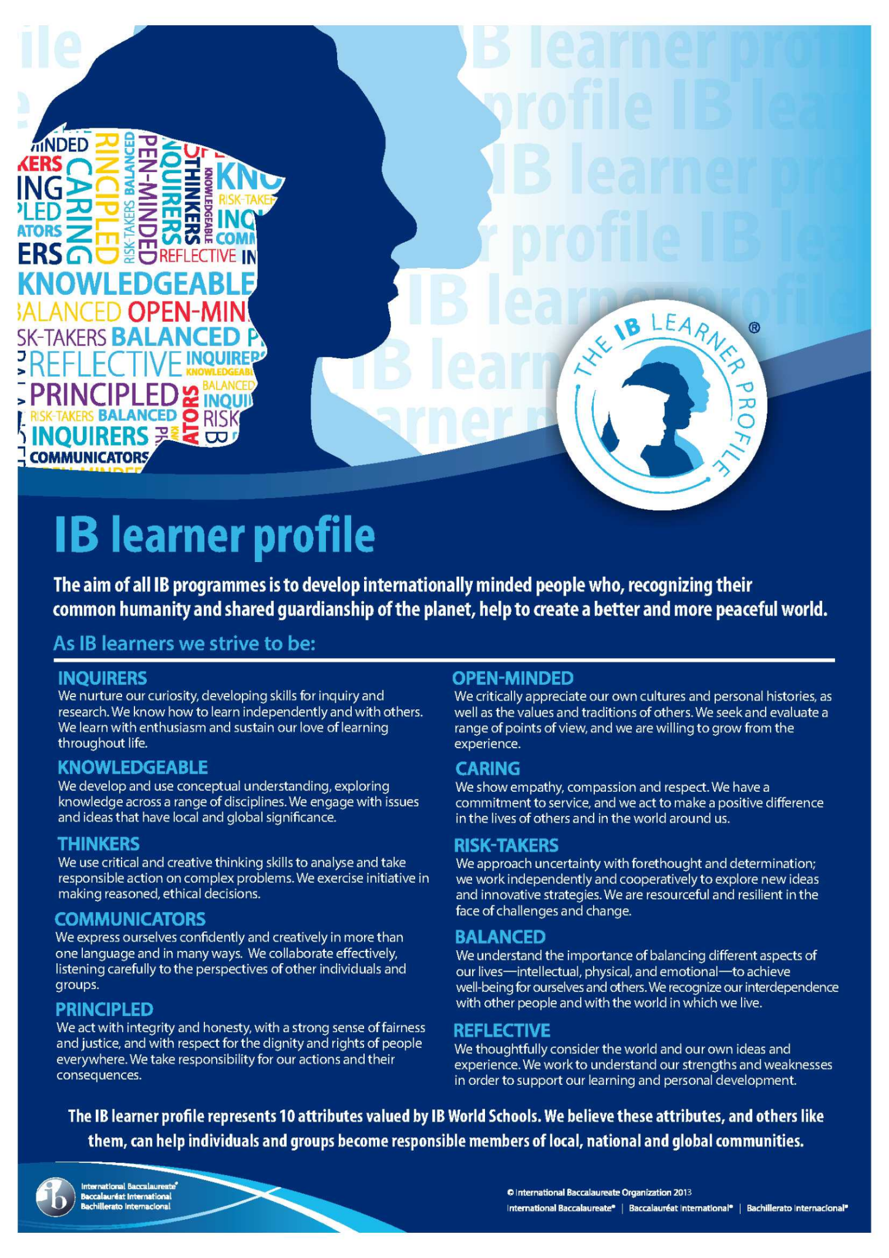

International Baccalaureate Learner Profile, © International Baccalaureate, Published July 2007

**CONTENTS**

1. Background 5

2. Admissions Statement 5

3. Admissions Process 6

3.1 Early Years Programme & Primary School 6

Advertising of Availability of Places 6

Visit to the School 6

Initial Registration 6

Processing of Applications for Early Years Programme and Grade 1 6

Processing of Applications for Grades 2 to 4 7

Entrance to Grade 5 7

3.2 Middle School 7

External Students for Grade 5 Entrance 7

Entrance to Middle School: Grades 6, 7 and 8 7

3.3 High School 7

Entry into Grades 9 to 12 8

IB DP Entry Requirements 8

3.4 Special Educational Needs Admissions 9

4. Withdrawals 9

5. Documents Required on Application and Registration 9

APPENDICES 9

APPENDIX 1: High School Entrance Assessment Aims, Regulations, and Examples: 9

APPENDIX 2: School website URLs for parents wishing to register to the schools 9

1. **Background**

Özel Bilkent Schools are an International Baccalaureate (IB) Continuum World School and provide education based on the principles of an IB education from ages 4 to 18. In accordance with the Turkish Ministry of Education’s 4-year Primary, 4-year Middle, and 4-year High School education system, our Primary Years Programme ends at Grade 4, and our Middle Years Programme begins with Grade 5.

The Primary School offers the IB Primary Years Programme (PYP), authorised in 2012, which is a transdisciplinary programme including the Early Years Programme (ages 4 to 6), and Grades 1 to 4 (ages 6 to 10); a total of 6 years. The first cohort to complete the PYP exhibition was in 2016.

The Middle School offers the IB Middle Years Programme (MYP), authorised in 2018, which offers a framework of subject-specific and interdisciplinary understanding from grades 5 to 10 (ages 11 to 15), crossing from the Middle School, Grades 5 to 8, to the High School’s first two years, Grades 9 and 10; a total of 6 years. The first cohort to complete the E-Assessment requirements was in June 2023.

All students who receive an education from the Özel Bilkent Schools (Early Years through Grade 10) will be provided with an IB education while adhering to the Turkish Ministry of National Education (MEB) requirements.

The final two years of High School, Grades 11 and 12 (ages 16 to 18), give students the opportunity to choose between the IB Diploma Programme (DP), authorised in 2008, or the Turkish MEB programme. Both tracks allow students to study for the university entrance exam, however those studying the IB DP have the chance to attain both a national high school diploma and IB diploma.

1. **Admissions Statement**

The schools provide parents with the possibility of having their children follow a high quality IB Continuum education from an early age. This framework ensures that students graduate with well-formed global perspectives, with an inquiring mind-set, with the necessary academic and critical skills to be successful in their chosen university programmes, and with an awareness of the needs of their society and with the ability to organise for the fulfilment of those needs.

The schools support the provision of a rigorous educational experience for students and actively seek parents and students who wish to experience an education which will develop their talents, academic skills, and social awareness, and prepare them for global citizenship.

Özel Bilkent Schools pursue an open admissions policy and welcome students from all nationalities but recognise that the current school catchment population is mainly comprised of Turkish nationals, with a small number of families from other nationalities, with bi-lingual backgrounds. This recognition shapes the delivery of the curriculum in meeting the future needs of students. The schools make it clear to prospective families and pupils that our curriculum, while shaped by the IB international framework, is bound by MEB requirements and curriculum so that families can make the right choices according to their educational preferences.

Özel Bilkent Schools provide support for those for whom Turkish is an additional language but seeks to convey clearly to parents the challenges that accompany acceptance of those with reduced competence in Turkish relative to the class level in which they integrate into the school. English is the second language of the schools and students start learning English in a bilingual environment in the Early Years Programme. This means that as students progress through the school, they have the chance to become proficient in their English language skills.

The schools are therefore also committed to ensuring that new admissions are able to integrate at the required level into the relevant English phases offered to the year group suited to their age.

1. **Admissions Process**

Each of the three schools welcomes admissions from all parents who wish to enrol their children. Each school specifies its ***admissions process*** clearly on its school website and admission is completed via the school’s K-12 system (see Appendices for website links). The ages for assignment to levels follows those set out by the Turkish Ministry of Education (Temel Eğitim ve Ortaöğretim Kurumları Yönetmeliğinde: <http://meb.gov.tr>).

The schools communicate clear ***admission requirements*** to prospective families through the website of each school, with clear dates specified for the process of admissions. Each school accepts students through a set of criteria relevant to the school in question, which recognises the need to account for factors mentioned above, as well as the ability of students to integrate successfully into the requirements of the IB programmes.

Currently demand outstrips capacity of the schools to accept all students, therefore a selection process is operated by each of the three schools as follows:

* 1. **Early Years Programme & Primary School**

*Advertising of Availability of Places*

* Availability of places in the primary school is advertised online on the school’s web page prior to the date on which applications are accepted. Opening and closing dates for initial application are clearly provided on the website.

*Visit to the School*

* Information meetings are prepared by the school to which all interested parents are invited. Information meetings are led by the General Coordinator, the Principals and Vice-Principals. These meetings provide background information, allow parents to get familiar with the school’s approach to education, and provide parents with a tour of the school, with the appropriate level teachers, and the opportunity to ask questions and receive further detailed information.

*Initial Registration*

* Parents who are interested in registering their students are asked to complete online procedures and relevant documents giving information, including age, desired entry level, previous education if relevant, family details, and other background information related to the child (special educational needs, etc.). A registration fee is charged for the processing of applications.

*Processing of Applications for Early Years Programme and Grade 1*

* Once registration closes, those families who have applied are called to the school with their child at times specified by the administration for an entry process. This usually takes place on a weekend after registration is closed.
* The entry process requires applicants to bring their children to the school for a personal interview with the school counsellors. Children are also placed into a group of similarly aged children and observed by classroom teachers. After the individual interview, prospective students participate in a group activity with their peers to observe their communication skills.
* The counsellors and classroom teachers then draw up a list of eligible students based on selection criteria, and the families of those admitted are informed of their right to enrol their children in the school. The list also includes families whose children are on standby, should one from the former list withdraw.
* Parents are given a specified time to register after which their right to enrolment is no longer valid.
* Registration requires the payment of the educational fee by the date provided, upon which registration is secured.
* In the case of non-payment by the date required, the school progresses to the stand-by list and offers the opportunity to register based on the order designed at the interviews.

*Processing of Applications for Grades 2 to 4*

* The registration process mirrors that for the pre-school and Grade 1, but the selection process incorporates a test of knowledge, skills and attitudes based on curriculum expectations, as well as an interview with the counsellors, and selection is made accordingly. Those who meet the set criteria are invited to register. Again, a stand-by list is developed depending on availability of places and operated if the registration requirements are not completed as required by those eligible.

*Entrance to Grade 5*

* Records for all students at the Primary School are kept and are forwarded to the Middle School for those students wishing to continue at Özel Bilkent Schools. The primary school supports students in Grade 4 who may need help, with a view to strengthening the knowledge and skills they will need in Grade 5/MYP.
  1. **Middle School**

The middle school is authorised for the Middle Years Programme (MYP) and all students accepted follow the IB MYP framework.

*External Students for Grade 5 Entrance*

* Entry into the fifth grade is based on the student's performance in a written examination determined by the school. Registration for the entrance exam, necessary procedures, conditions, dates and examples of the evaluation system are published as a separate publication at least two months before the exam and as a booklet on the school's website with timetables.
* As written in the School Regulations, accepted by the Turkish Ministry of National Education (MEB), the entrance exam requires students to exhibit required levels of ability in their first and second languages, Turkish and English respectively, and mathematics.
* Once the exam has been taken, students are ranked according to their performance in this exam.
* A list of eligible candidates is drawn up and families are invited to register their child(ren) within the required timescales advertised, and according to the availability of places.
* External students who are accepted to the Middle School are assigned to English phases (levels) according to their performance in the entrance exam from the English language assessment section.
* If the available quota is not filled, the student recruitment exam may be reopened to prospective candidates in June. Information about the exam to be held in June is made available on the school website at least 2 months in advance.

*Entrance to Middle School: Grades 6, 7 and 8*

* Registration to Grades 6, 7 or 8 follows the same advertising, information provision, and initial registration as for the Primary School (see above and visit the school’s website).
* Once registered, students are invited to sit a test covering their knowledge in Turkish, English and mathematics.
* Students who are successful in the entrance exam are invited to register to the school, depending on the availability of places, within the timescales as advertised on the school’s website.
* If the available quota is not filled, the student recruitment exam may be reopened to prospective candidates in June. Information about the exam to be held in June is made available on the school website at least 2 months in advance.
  1. **High School**

The High School follows the IB MYP programme (years 4 and 5) for all students in Grades 9 and 10. The school provides a choice of programmes for Grades 11 and 12. Parents and students may opt to either follow the IB DP (which incorporates the MEB programme) or focus solely on the MEB curriculum. Entry to the IB DP is based on criteria, outlined below. The registration process, with important deadlines, is posted on the school’s website and the necessary application is made online.

*Entry into Grades 9 to 12*

* Entry to the High School is competitive for all students, those from the Özel Bilkent Middle School and those applying from other schools.
* Acceptance to the high school is based on acceptable performance on an entrance exam, viz. a test of English, Math, Turkish, Social Sciences and Science. The tests are administered on a single day in May and families are notified of the outcome within two weeks.
* Those eligible are invited to register within a required period, along with payment of the necessary fee instalment, as advertised online. Registration is secured once this has been done.
* If additional places exist, then a second entrance exam will be run in the period prior to the new academic year. Acceptance will mirror the rules for the first exam and registration will depend on satisfactory performance in the entrance exam and payment of fees by the date specified.
* The school may decide to accept students through the national high school entrance exam (LGS) which is administered by the Turkish Ministry of Education (MEB), if places are available and if the students meet the minimum criteria specified by the High School.

*IB DP Entry Requirements*

Students who intend to continue in the IB DP in grades 11 and 12 should meet some requirements to be admitted to the programme. These requirements are in place to protect students’ wellbeing and prevent possible disappointments students might experience because of lack of linguistic, mathematical, scientific ability or knowledge. Currently, the entrance requirements for the IB Diploma Programme are:

* No failing grades in Grade 10;
* Having a minimum GPA of 75/100;
* Passing an internationally recognised English exam by the end of Grade 10.
  + TOEFL ITP is the recommended exam for this age group and purpose as some other internationally recognized exams may be too challenging due to their content. Students require 550 points from the TOEFL ITP English examination to enter the DP. Students scoring between 550 and 580 are generally placed in English B classes, with students scoring 580 and above being placed in English A classes. Exceptions may be made based on desired university requirements and interviews with the DP coordinator/school administration provided the class is still at the appropriate level of challenge. The school makes necessary arrangements for Özel Bilkent students to take the TOEFL ITP exam at school at a reasonable price to make it more convenient for them and to support them in their DP preparation journey;

Alternatively, students may sit one of the following internationally recognized English exams.

* + 75 in the TOEFL IBT exam, with a minimum of 17 in each paper;
  + An average of 6.5 in the IELTS Academic examination, with a minimum of 6.0 on each section;
  + A-A**\*** in IGCSE English Literature for IB DP English A and a minimum C-B in IGCSE English Literature for IB DP English B.
  + A ‘B’ Grade in the Cambridge English First Certificate Examination (FCE)
  + ‘Pass’ in the Cambridge Proficiency in English (CPE).

Students are allowed to sit the exams multiple times and to resubmit English scores until the end of grade 10 in order to be accepted into the DP or to be accepted into an English A course. When students can’t pass the English test by the end of Grade 10, an extension into the summer months *may* be obtained upon approval of the school administration. (Please see the Language Policy for further details about English A and B levels).

* A recommendation from Grade 10 subject teachers as to preparedness of the student to meet the Diploma Programme requirements based on pre-specified criteria. (When teachers think students should not select a course or lack some concepts, they guide the students regarding which materials they should cover to improve themselves or which courses/levels they should consider to make logical, realistic university plans;
* An acceptable attendance record;
* An acceptable disciplinary record;
* A signed contractual agreement by student and parent that they have read and accepted the conditions related to registration to the Diploma Programme;
* Completed high school registration requirements and payment of fees.

**3.4 Special Educational Needs Admissions**

During all registration processes to the three schools, families are asked to make known any disability or special educational need which may affect a student’s ability to take full advantage of the education provided at the school. Should special educational needs or disability become apparent after admission, the school will consult with parents about reasonable adjustments that may allow the student to continue at the school. (See our Inclusion policy for information about teaching and learning provisions made for special needs students).

1. **Withdrawals**

Intention to withdraw from the registration process of one of three schools should be given in writing prior to the deadline announced on the school’s website in order to obtain a full refund of application fees. Families who withdraw students *afte*r registration are required to submit a petition regarding the student’s withdrawal. Withdrawals may be made except during the last three weeks of each semester in accordance with MEB regulations. In such cases, a 10 percent fee is charged and the remainder of the school fee is reimbursed.

1. **Documents Required on Application and Registration**

* The documentation required for application and eventual registration is outlined on the Primary, Middle and High School’s website.
* All information given by parents related to their own situations and those of the child(ren) remains strictly confidential to the school in accordance with Türkiye’s Personal Data Protection Law (KVKK) and is not communicated to any other persons without express permission of the families concerned, other than to those who need the information for registration purposes.

**Appendices**

**APPENDIX 1**

High School Entrance Assessment Aims, Regulations, and Examples: <https://obl.bilkent.edu.tr/index.php/tr/>

**APPENDIX 2**

School website URLs for parents wishing to register to the schools

High School: <http://www.obl.bilkent.edu.tr/index.php/en/>

Primary and Middle Schools: <http://www.obi.bilkent.edu.tr/>