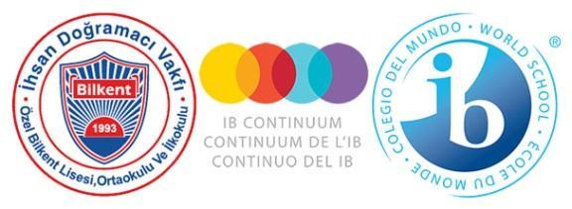

**Özel Bilkent Schools**

**INCLUSION POLICY**

**FOREWORD**

The Özel Bilkent Primary, Middle and High Schools wish to thank the students, parents, academic and administrative staff, who have contributed to the renewal and development of our school policies by participating in the process of formulating and recording our beliefs and procedures in the following policy documents: Child Protection Policy; Admissions Policy; Language Policy; Academic Honesty Policy; Assessment Policy; Inclusion and Special Educational Needs (SEN) Policy.

Our schools were established in 1994. Thanks to the support and feedback of our school community over the time since its foundation, we have witnessed strong growth in the numbers of parents wishing to offer their children an internationally minded education with us. The latest stage in our development was the authorization for the Middle Years Programme in 2018, which, by connecting the Diploma and Primary Years Programme, has ensured the consistent application of our curriculum philosophy across the three schools.

We welcome comments and constructive feedback on all our policies in order to contribute to further development and improvement in the delivery of our curriculum.

As a school community we are committed to working together to ensure that these policies are applied effectively, kept up to date, and adhered to within a positive mindset to the benefit of the whole school community.

This policy was last revised in May 2025. It will be revisited at the beginning of each academic year, or as needed in coordination with programme coordinators, teachers, administrators, parents and students.

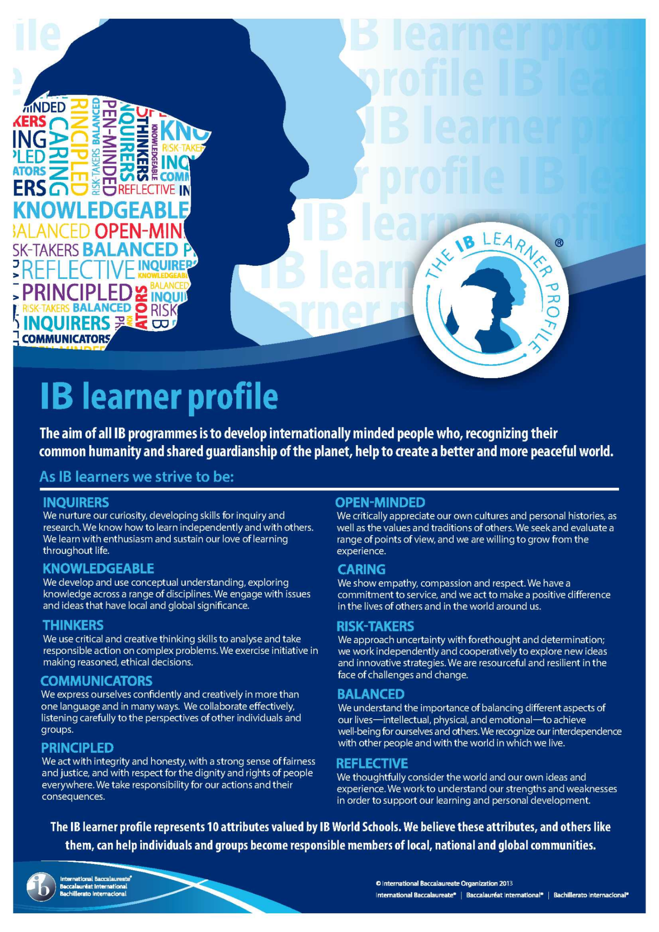

International Baccalaureate Learner Profile, © International Baccalaureate, Published July 2007

**CONTENTS**

1. Respect and Tolerance to Diversity and Difference 5
2. Inclusion in the School Community 6
   1. Awareness-raising and Celebration of Diversity 6
   2. Countering Prejudice in the Broader Community 6
   3. Inclusion Reflected in the Curriculum and Inquiry 6
   4. Actions to Ensure Gender Equality 6
3. Special Education in our School Community 7
   1. Basic Principles and Beliefs about Inclusion 7
   2. Identifying Individuals with Diverse Needs 8
      1. Individuals with Special Needs 8
      2. Individuals with Special Educational Needs 8
      3. Specially Talented and Gifted Students 8
4. School Practices Regarding Inclusive Arrangements 9
   1. Special Education Teacher(s) 9
   2. Student Counsellors 9
   3. National Regulations 10
   4. Shadow teachers/Helpers 10
   5. Physical Environment and Materials 10
5. Admission of SEN students to Private Bilkent Schools 11

References 12

1. **Respect and Tolerance to Diversity and Difference**

The global community astonishes us daily by confronting us with its creative diversity, thus challenging us to rethink our place within that community, and how we can value that diversity with a view to creating a more tolerant and peaceful world. It is our belief that communities of learners who reach out to embrace and include diversity in their aspirations are more able to work towards a sustainable model of harmonious living and to address the issues which are at the forefront of global concerns going into the future.

An IB education in our view is about establishing a foothold of respect and tolerance in communities, particularly where current practices do not reflect an ideal model, in order to spread a message which recognizes the right for all members of any community, be they global, national, local, or familial, to be accepted and valued for their differences. Diversity expresses itself in many ways, including gender, age, race, ethnicity, cultural background, physical and mental ability, socio-economic status, religion, sexual orientation and language. Our policy recognizes that members of the school community should make a constant effort through its educational practices to eliminate prejudice in whatever form so that those who differ in their diverse orientations or personal characteristics can develop as fully accepted members of the communities of which they are a part and reach their full potential.

All members of the community should be accepted for who they are, should feel valued, cared for, understood and trusted. The school makes every effort to ensure that they are valued for their strengths, set realistic expectations yet challenged in their learning, heard and listened to, and provided with an opportunity to participate in decision-making. The school recognizes diversity only in so far as it provides differentiated learning opportunities which reflect an individual’s needs, but the school does not disregard prejudice of any sort towards those who are different in their orientations or capacities. The school actively promotes understanding, tolerance, and inclusion so that diversity is valued as a positive contributor to the culture of the school and community.

This document outlines the practical steps that the school community takes in promoting diversity and tolerance of diversity, and links to other policies and practices outlined in the Admissions, Language, Assessment and Academic Honesty Policies. IDF Özel Bilkent Schools seek to ensure that all student needs are addressed, and provision made available to them throughout their school career. The school acknowledges the right of all students to a broad and balanced curriculum which is inclusive, reflecting diverse needs and facilitating opportunities to create a culture in which such needs are valued.

Özel Bilkent Schools *Inclusion and Special Educational Needs Policy* has been collaboratively developed with students, parents, teachers and administrators, while considering the Rules and Regulations on Special Education and Guidance Services of the Turkish Ministry of Education, the Declaration of Rights of the Child, the United Nations (UN) Convention on the Rights of Persons with Disabilities, and IB documents: Inclusion within the International Baccalaureate Programmes, The IB Guide to Inclusive education: A Resource for whole School Development, Meeting Student Learning Diversity in the Classroom, Learning Diversity and Inclusion in IB Programmes, Making the Primary Years Programme (PYP) Happen; Middle Years Programme (MYP): From Principles into Practice; IB Diploma Programme From Principles into Practice guides (2020); and the IB Learner Profile. The policy is accessible through the school’s website for everyone.

1. **Inclusion in the School Community**

Inclusion is a process of participating all students with a culture of collaboration and problem-solving in the school community.

**2.1 Awareness-raising and Celebration of Diversity**

The school considers barriers to learning from multiple perspectives and promotes inclusion of all students. Diversity within the school community does not create a barrier to learning and the school promotes acceptance and celebration of diversity through written and hidden curricula. The leadership team is involved in developing effective strategies to increase access and participation. Daily interactions within the school community create affirmative, responsive environments that promote a sense of belonging, safety and self-worth for every member of the community. The learner profile plays a role in promoting the agency to affirm identity and the school supports access for all students to the IB programmes and philosophy.

**2.2 Countering Prejudice in the Broader Community**

The school develops and implements policies and procedures to encourage students’ counter prejudice in their lives and in the broader community. The school provides support for its students with learning needs and support for their teachers.

**2.3 Inclusion Reflected in the Curriculum and Inquiry**

The school fosters an inclusive curriculum by incorporating differentiation and universal design for learning into its units of inquiry to address the diverse needs and learning styles of all students. Learning materials and lessons are designed with engaging content that emphasizes understanding, respect, and international mindedness, while also promoting students' reflection skills. Teaching and learning focus on human commonalities, diversity, and multiple perspectives, ensuring a dynamic and respectful environment that meets individual learning needs and nurtures thoughtful engagement.

**2.4 Actions to Ensure Gender Equality**

Common understandings, policies and practices take into account gender equality, human rights, and diversity. All members of the school community are responsible for developing culture and practices that provide equal opportunities for all regardless of their age, gender, culture, race, ethnicity, languages, life preferences, life conditions and/or being above or below the norm with respect to learning abilities.

1. **Special Education in our School Community**

The IB supports the following principles of an inclusive education where:

• education for all is considered a human right

• all learners belong and experience equal opportunities to participate

and engage in quality learning which enables them to achieve their full potential through differentiated, engaging, and meaningful learning experiences

• every educator is an educator of all students

• learning is considered from a strength-based perspective

• assessment provides all learners with opportunities to demonstrate their

learning, which is rewarded and celebrated

• all students experience success as a key component of learning

*read further in Learning Diversity and Inclusion in IB programmes (2020)*

Our school helps all students to become productive members of the community who fulfill their social roles, are adapted to their surroundings, and can work cooperatively and harmoniously, equipped with the life skills needed in order to live independently and self-sufficiently. Each student learns, works and produces in order to expand their potential. For this purpose, the school works in collaboration with the Ministry of Education and medical institutions to provide an appropriate social, psychological and academic environment which takes into consideration each student’s abilities and needs.

## **3.1. Basic Principles and Beliefs About Inclusion**

The school has a sustainable and an organized structure in terms of the implementation of common decisions, where environments are created in which students can feel safe physically, emotionally and academically and where adults are easily accessible to help solve problems. Individuals with special needs use special educational services to the extent of their educational needs, interests, abilities, and capabilities.

Educational services are planned and carried out for individuals with special needs by taking support from relevant institutions, organizations and experts, and which ensures that such education does not separate individuals from their social and physical environment nor from their peers to the extent this is possible.

A reliable and fair method of diagnosis and evaluation is followed to ensure that individuals receive appropriate services to meet their specific needs.

An “Individualized Education Program (IEP)” is developed and implemented for students with special education needs as determined by the Ministry of Education. It ensures that families are educated and active participants in the special education process. Families are informed about their rights, opportunities, boundaries and communication mechanisms in the school regarding their special situation.

Creating positive attitudes in individuals with special educational needs is considered a way of eliminating prejudices about differences.

**3.2. Identifying Individuals with Diverse Needs**

There may be students who enroll at the school with a range of possible needs. Some of these students may already have been diagnosed by medical institutions and have special needs reports from the Ministry of Education; others may be diagnosed by teachers identifying students who have emotional, social, behavioral and learning difficulties as well as students who are talented/gifted in different areas. Upon suspicion of a learning difficulty or gifted situation, teachers complete observation forms and inform the Psychological Counselling and Guidance Unit (PCG). The PCG Unit comes together with the class teacher and branch teachers as well as the special education teacher to determine the situation of the student in question and decide on whether to request professional diagnosis and/or differentiated in-school practices. Objectives targeting students with special educational needs are formulated and assessed within the first month of the academic year, then these objectives are implemented in the school’s strategic plan.

Individuals with special needs that can be included in this scope are as follows:

**3.2.1. Individuals with Special Needs**

* Chronic diseases and diseases requiring a long treatment period,
* Physical challenges,
* Sudden trauma experiences (Situations that disrupt the daily routine, that create sudden or unexpected changes; that create horror, anxiety and panic confuse the interpretation processes of the person)

**3.2.2. Individuals with Special Educational Needs**

* Specific Learning Disabilities (dyscalculia, dyslexia, dyspraxia),
* Hearing Impairments,
* Visual Impairments,
* Speech, Language, and Conversation Impairment,
* Autism,
* Attention Deficit and/or Hyperactivity Disorder,
* Intellectual Disability Due to Mental Retardation,
* Talented and Gifted Individuals
* Social, Behavioral and Emotional Disorders
* Students from abroad with different language and/or cultural perspectives

**3.2.3. Specially Talented and Gifted Students**

The teacher who identifies a gifted or specially talented student in their class (Grades 1-3) reports this information to the Psychological Counseling and Guidance Unit. The school administration, the Psychological Counseling and Guidance Unit, and a committee consisting of class and branch teachers then direct the student to the Science and Art Center (BİLSEM) for diagnostic and placement evaluations, conducted nationwide in accordance with the conditions set by the Ministry of National Education (MEB). The families of students selected to participate in this evaluation process are informed by the school administration, and their approval is obtained. Families who consent to the process receive the evaluation entry documents provided by the MEB and ensure that their children participate in the exam.

Students who perform successfully in the BİLSEM pre-evaluation and individual evaluation processes are diagnosed as gifted or specially talented in one or more specific areas. These students then have the right to receive support education tailored to their talent areas at BİLSEM, affiliated with the MEB, on specific days and times of the week.

1. **School Practices regarding inclusive arrangements**

Coordination and cooperation between the administration, parents, students, teachers, support personnel and other units in the wider environment (medical support systems, special education institutions, individual support persons and organizations, etc.) are developed to encourage and manage inclusion practices.

Professional development needs of all school personnel in the areas of special education and inclusion are identified and cooperation of all stakeholders is sought for meeting professional development needs.

* 1. **Special Education Teacher(s)**

There is a Special Education Teacher working full time in coordination with teachers, coordinators, counsellors and parents to organize the inclusive education environment. The Special Education Teacher carries out the necessary studies and evaluations to determine the individual needs of the student who requires special education and informs the necessary people and units to provide the student with the most suitable environment.

The education plan is differentiated by the teacher according to the needs of the student, taking into account the characteristics and competencies of the individual in all developmental areas. With a student-centered approach, the teaching programs are created and updated in line with the developmental profile and temporary/permanent needs of the students.

* 1. **Student Counsellors**

Counsellors provide information that improves understanding, positive attitudes, encouragement and problem-solving approaches in the staff who teach students with different needs and support them when necessary. Coordination and cooperation between the school administration, teachers, students and parents are ensured by the counsellors. The required approach is determined and a targeted intervention programme (TIP) is designed by combining the general profile of the student with the opinions of all teachers, PCG and family. The process is monitored through regular evaluations, observation reports and feedback. If the targeted intervention programme meets the needs of the student, it is continued; if it does not, the necessary guidance is provided.

* 1. **National Regulations**

The student who is determined to be suitable for special education by official institutions continues her/his education within the Inclusive Education Program at our schools. The school carries out the legal process in accordance with the expectations of the Ministry of National Education for students who are medically diagnosed or who have documented different educational needs. At the end of the process, individuals are directed to support training programs appropriate for their needs, according to the report results of the special education evaluation board. The Individualized Education Program Development Unit (IEP-DU) consists of the relevant teachers, vice principal, parents, students, guidance teacher and special education teacher under the chairmanship of the school principal. The responsibility of the Individualized Education Program Development Unit (IEP-DU) is to coordinate the preparation, implementation, monitoring and evaluation of the Individualized Education Program (IEP) developed for students with special education needs. With the cooperation of special education and subject teachers, an individualized education program for each unit is planned for the subjects needed. Course materials, assignments and evaluations are prepared in accordance with the individual development of the student. When appropriate and necessary, studies can also be carried out in a separate “support” room with the suggestion of the Individualized Education Program Development Unit (IEP-DU) for students who will receive individualized education programs with a special education teacher. Teaching materials, including Information and Communication Technology, are differentiated according to the needs and requirements of the student. The assessment is based on the IEP and is consistent with the school's assessment policy.

Results are recorded and archived, and files are kept for the entire educational period of the student. The Individualized Education Program Development Unit (IEP-DU), whose duties and responsibilities are clearly defined, meets regularly with parents and / or students as specified in the Ministry of National Education Regulation.

Group or individual support education activities are carried out in our school for the special ability areas of gifted students who are successful in the BİLSEM exams held by the Ministry of National Education at the primary school level and recognized by official institutions. Students are given the opportunity to demonstrate their talents and work.

* 1. **Shadow Teachers/Helpers**

When needed, the school can request parents to assign a shadow teacher or helper to the school / classroom to meet the special needs of the student. An action plan is prepared in cooperation with the PCG, classroom teacher and / or branch teacher and parents to create a special study program for the student.

* 1. **Physical Environment and Materials**

If a regulation is required regarding the physical environment or any materials in order to meet the special needs of the student, the condition is conferred with the school administration and relevant individuals about facilitative solutions. All students are encouraged to be as independent as possible. Necessary arrangements are made for students to participate in social, artistic, cultural and sports activities in line with their individual profiles.

1. **Admission of Special Needs Students to Özel Bilkent Schools**

Necessary arrangements are made for prospective students with special needs upon entering our schools. (See School Admission Policy)

When individuals with mild or moderate needs are accepted to IDV Private Bilkent Schools, they continue their education at our school unless they choose to leave or up to a point where the school is no longer able to support their intensive special needs.

**References**

* Guidance for Writing A Special Educational Needs Policy Post-Primary Development Group. CASS, Schools and Special Education Working in Partnership June 2011.
* Rules and Regulations governing Special Education Services of the Ministry of National Education.
* Rules and Regulations governing Psychological Counselling and Guidance Services of the Ministry of National Education.
* MoNE and EU Project on Strengthening Special Education, School without Barriers Model Road Map, Standards and Performance Indicators, June 2013, Ankara.
* MoNE and EU Project on Strengthening Special Education, Teacher’s Guide to Inclusive Education Practices, June 2013, Ankara.
* The IB Guide to Inclusive education: A Resource for whole School Development.
* PYP, MYP; DP and IB Career-related Certificate Meeting Student Learning Diversity in the Classroom, May 2013.
* Special Educational Needs within the International Baccalaureate Programmes, August 2010.
* IB Continuum Learning Diversity and Inclusion in IB Programmes, January 2016.
* IB Standard and Practices 2020.