;

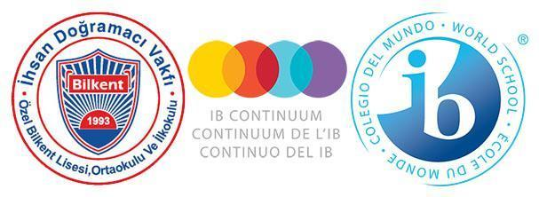

**Özel Bilkent Schools**

**LANGUAGE POLICY**

**FOREWORD**

The Özel Bilkent Primary, Middle and High Schools wish to thank the students, parents, academic and administrative staff, who have contributed to the renewal and development of our school policies by participating in the process of formulating and recording our beliefs and procedures in the following policy documents: Child Protection Policy; Admissions Policy; Language Policy; Academic Honesty Policy; Assessment Policy; Inclusion and Special Educational Needs (SEN) Policy.

Our schools were established in 1994. Thanks to the support and feedback of our school community over the time since its foundation, we have witnessed strong growth in the numbers of parents wishing to offer their children an internationally minded education with us. The latest stage in our development was the authorization for the Middle Years Programme in 2018, which, by connecting the Diploma and Primary Years Programme, has ensured the consistent application of our curriculum philosophy across the three schools.

We welcome comments and constructive feedback on all our policies in order to contribute to further development and improvement in the delivery of our curriculum.

As a school community we are committed to working together to ensure that these policies are applied effectively, kept up to date, and adhered to within a positive mindset to the benefit of the whole school community.

This policy was last revised in May 2025. It will be revisited at the beginning of each academic year, or as needed in coordination with programme coordinators, teachers, administrators, parents and students.

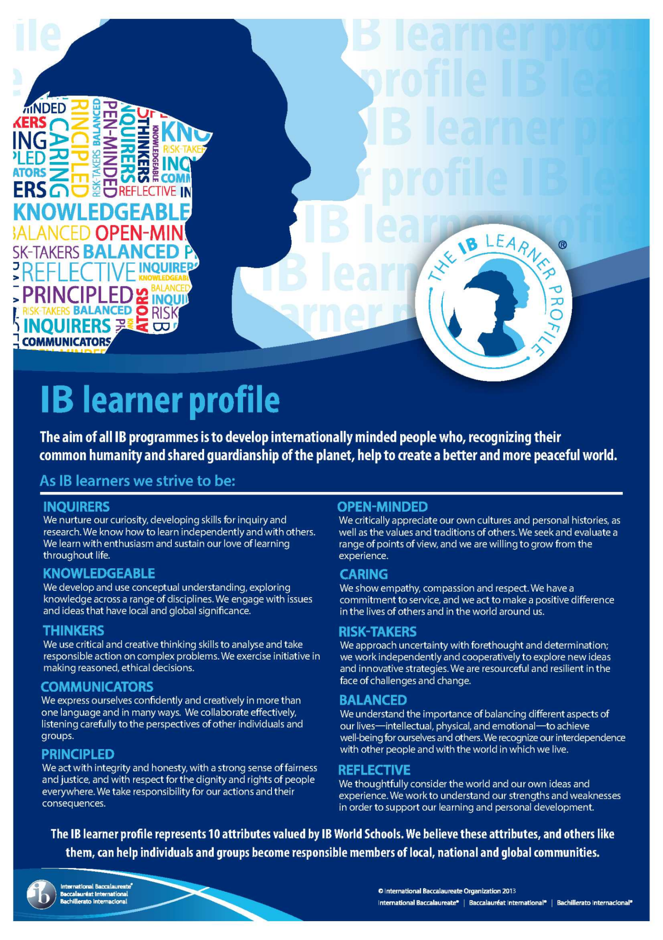

International Baccalaureate Learner Profile, © International Baccalaureate, Published July 2007

Table of Contents

1. Our Language Philosophy 5
2. Language Profile 5
3. Development Process of the Language Policy 5
4. Fundamental Beliefs about Language 6
5. Student Placement and Progression 9
6. Roles and Responsibilities 12
7. Differentiated Instruction 13
8. Özel Bilkent Libraries 14
9. Articulation of the Language Policy with other School Policies 15

Works Cited

16

# Our Language Philosophy

At Özel Bilkent Schools, we believe language is a vital tool for fostering national identities, promoting international-mindedness, and transmitting cultural values across generations. We strive to create an environment where students are immersed in diverse cultures and develop an appreciation for bi/multilingualism.

Our primary language of instruction is Turkish, with English taught as a second language across all grades. Starting in Grade 4, students can opt to learn French, German, or Spanish as additional second foreign languages. From Grades 5 to 12, students engage in an intensive, inquiry-based language curriculum, differentiated into the three IB Language Acquisition proficiency levels—emergent, capable, and proficient—tailored to their academic achievements and individual needs.

This commitment to bi/multilingualism is also reflected in our communication practices, with materials and visuals prepared in Turkish and English, and, when necessary, in additional languages. Our Language Policy aligns with the IB philosophy, emphasizing the development of internationally-minded, lifelong learners who are open to personal growth and intercultural understanding.

Guided by this approach, our Language Policy aims to equip students with the skills to explore diverse cultures and ways of thinking. Activities such as critical thinking exercises, research projects, presentations, debates, and festivals foster these skills and support our mission to nurture thoughtful and inquiring individuals prepared to thrive in a globalized world.

# Language Profile

In our endeavor to develop fully educated individuals, we believe that language plays a key role at Özel Bilkent Schools.

The majority of our students are Turkish nationals, however, our school is open to students from all countries, cultures and nations. Language competence, despite differing from one culture to another, is a uniting element for all humans and offers a chance to develop common understandings among cultures. The school environment recognises students’ and teachers’ differences, and we prepare visuals representing the different languages and cultures which are displayed across the three schools. Students whose native language is not Turkish are given individual Turkish language support and provisions are made to ensure that the student’s home/personal language are included in school displays and in library resources.

# Development Process of the Language Policy

Our language policy is based on the principle of nurturing a love of language to develop an understanding and appreciation of the cultures of other languages and to serve as a link between the IB Primary Years Programme (PYP) and Middle Years Programme (MYP) to the Diploma Programme (DP) and Turkish national education track.

*“A language policy is an action statement… it is concerned less with where the students in a school are going, and more with how they are going to get there” (Corson, 1999)*

The Language Policy has been developed in consideration of the IB PYP, MYP, and DP ‘Language Guides’ and in accordance with Ministry of Education (MEB) regulations. The policy is a product of a collaborative process involving students, teachers, and administrators from the three schools which have become one IB Continuum School. The aims of the policy include:

* clearly laying out the principles about language teaching and learning for teachers and all members of the school community;
* establishing a common understanding and approach to language to ensure that implementation reflects the purpose;
* adopting a shared attitude towards assessment and feedback given to student work;
* raising awareness about the importance of following spelling and punctuation rules;
* adding variety to library resources in foreign languages;
* offering differentiated instruction to students with different skills and language levels;
* promoting international-mindedness and Learner Profile attributes.

The School Principals, IB Coordinators, Unit Coordinators, Head of Department and teachers of Language A: Literature, Language and Literature, and Language B: Language Acquisition, all subject teachers, school librarians, administrative personnel, students, and parents are responsible for contributing to and following this Language Policy. The policy is available to all members of the school community on the website.

# Fundamental Beliefs about Language

Özel Bilkent Schools holds the following eight fundamental beliefs about language education:

1. **Like all other types of learning, language learning is a constructive process where learners construct meaning.**

Language development activities at Özel Bilkent Schools are inquiry-based and are framed by the three IB programmes (PYP, MYP, DP). These activities constitute a continuum where the past learning experiences of the individual are constructed and real-life learning opportunities are provided. The four basic communicative skills - listening, speaking, reading and writing - as well as IB Approaches to Learning (ATL) Skills are the main tools used in all lessons for language development. Oral and written self-expression of the individual is regarded not only as an effort to present meaning, but also as an attempt to construct, reinforce and capture the essence of meaning.

1. **All teachers are, in practice, also language teachers with a responsibility to facilitate effective communication.**

The school promotes the idea that all teachers are language teachers. Teachers should be models while teaching the language of their subjects and check dictionaries and pronunciation guides or seek the opinion of their colleagues when preparing documents and lessons for their students. All teachers work to improve their students’ listening, speaking, reading and writing skills in their subject group. For example, science and mathematics teachers are responsible for teaching literacy regarding numbers, charts, graphs, report writing, etc. while Social Science teachers improve students’ abilities to communicate through the use of maps, directions, and coordinates.

Teachers model effective listening and speaking skills and create opportunities for students to listen to each other. The effectiveness of students’ self-expression forms a part of assessment in all written and oral presentation tasks. Considered active readers by their students, teachers talk to their students about books and newspaper articles, periodicals and e-journals, have books with them for personal use, and are seen while reading during and outside the school. Irrespective of their subject areas, teachers strive to increase the students’ comprehension as well as their oral and written expressions.

1. **All students in the school aspire to reach the highest possible level of linguistic and cultural competence in their mother tongues, in English, and in French, German, or Spanish (if chosen) in order to develop a clear identity and cultural awareness and to use their self-expression potential to the full.**

***Mother tongue*** instruction serves social and academic communication purposes. Literature is a key resource in facilitating language learning in meaningful contexts. The school’s choice of literary works in Turkish and works in translation includes both classical and contemporary texts. Students are immersed in authentic, written and oral forms of narration in both fiction and non-fiction. Rules of the language are taught to, and elicited from, the students in a meaningful context. The school setting immerses students in language. The classrooms and corridors are full of samples of students’ work, and the school libraries are in abundance with books. Students are encouraged to express themselves in a variety of situations both in and out of the classroom, through written and oral production.

The ***first foreign language*** at Özel Bilkent Schools is English and every student is immersed in English language, literature and culture from the Early Years programme through to Grade 12. English is taught and learned through meaningful contexts, for social, academic and expressive purposes in order to contribute to international mindedness and cross cultural communication. Literature plays a significant role as a resource for teaching and learning English in meaningful contexts and the English Department’s choice of literature includes a balance of classic and contemporary, local and global, fictional and nonfiction works. Similar to their first language, students are also encouraged to express themselves in a variety of situations both in and out of the classroom, through written and oral English production.

The main aim of our ***second foreign language programme*** is to arouse an interest in learning a second foreign language (French, German or Spanish). By the end of Grade 12, students are expected to be able to use the language in daily life without being afraid of making mistakes, and to have learnt aspects of the culture of the relevant language. Students in German and French are supported by their second foreign language teachers should they choose to pursue external qualifications in internationally recognized external exams (G*Fit in Deutsch A1* and *DELF* exams) through extra lessons and differentiated materials.

1. **All students aspire to reach the highest possible level of linguistic and cultural competence in English and Turkish (and a third language if they choose) to lead a more meaningful life and to respond to the challenges uniting humanity by contributing to intercultural communication and understanding.**

Teachers and students are encouraged to spend quality time in the library, which accommodates a wealth of easily accessible resources. With a view to enabling them to become active readers, the students are offered opportunities to engage in individual reading. Starting from early years, our students have opportunities to look through many books from the library, class libraries and online platforms during English and Turkish classes. Our Library and class lessons help to foster an early love books and  provides language development as they learn new words and phrases. As students grow, they are encouraged to read in both subject areas and in areas of their own interest both in and out of class, online and in the library. They not only see examples of good language use, but are also guided to quality websites which provide additional learning opportunities. Both curricular and extra-curricular writing tasks assigned to students are adjusted to address the cognitive level of individual students in terms of content, difficulty level, and interest. Students who are given individual writing opportunities are empowered to adopt a holistic understanding of language with which they learn how to express themselves in writing. The school also provides opportunities for students to pursue their writing goals by taking part in publishing their own works in school magazines or books.

1. **All students are given the opportunity to learn a third language starting from fourth grade to expand their communication opportunities and to acquire a deeper understanding of the value and importance of a foreign language and its culture.**

In order to enrich students’ language learning, starting from fourth grade they are given a chance to study German, French and Spanish as their second foreign language. They study written and oral works from both fictional and nonfiction genres in order to increase their communicative competence and acquire a deeper understanding of the significance of learning and using a foreign language. Classrooms and libraries are equipped with various sources in all of these languages.

1. **The school embraces linguistic variety by valuing languages represented in the school or the homes of members of the school community.**

Home is a rich resource of language activity. Teachers are responsive to information provided by students and their parents about the richness of language. The variety of linguistic heritage is incorporated into classroom activities through inquiry-based methods. Teachers use the students’ awareness of their families’ linguistic past as a resource to achieve the aims of the language policy. Students and teachers are offered opportunities to learn more about the culture and heritage of groups speaking different languages, including their literature, traditions, music and expression systems. The inquiry in the school consolidates students’ learning about the languages, literature and heritage of groups speaking other languages. The School considers and displays language variety in presentations, drama and many other visual displays and festivals. Languages other than those taught at the school and their cultures are represented in the library.

1. **The school’s curriculum involves clear methods designed to promote communication with other linguistic groups by learning about the individuals speaking other languages, sharing their experiences and identity perceptions, and promoting cultural exchange with them.**

In order to build connections with school communities in other linguistic areas, our schools invite speakers of languages other than those represented in the school. Teachers try to connect with speakers of languages not represented in our schools to enrich the learning experiences of students and use technology as a tool to introduce cultures of different languages to students. Students are encouraged to participate in intercultural trips and prepare assignments about intercultural topics and from intercultural perspectives.

1. **Language does not pose an obstacle to communication in the school.**

All official correspondence of the School is in both Turkish and English. The School undertakes to develop and implement an effective translation policy through professional translators. All work-related emails sent to the staff are in two languages. Ceremonies and displays organized in our schools involve elements in both Turkish and English. The schools’ personnel are proficient in another language as far as possible; teachers are encouraged to be proficient, and applicants who are proficient in more than one language are preferred in recruitment.

**i)** **Respectful and Inclusive Use of Language**

At our school, language is not only a means of communication but also a reflection of our values. All members of the school community—students, teachers, staff, and families—are expected to use language that is respectful, fair, and inclusive in all settings: in the classroom, during lessons, in the playground, in written and spoken communication, and in all internal and external interactions. Language must not be used to harm, exclude, stereotype, or incite bullying. Instead, it should foster dignity, belonging, and mutual understanding. Teachers and staff are expected to address any instances of inappropriate or harmful language immediately and to guide students in understanding the impact of their words. We believe that the words we choose shape the culture we create, and we are committed to maintaining a school environment where everyone feels seen, valued, and safe.

1. **Student Placement and Progression**

As Turkish is the mother tongue of our schools, all students study Turkish Language and Literature in each grade (K-12).

In the Primary Years Programme, from Early Years to Grade 4, both Turkish and English languages are given a lot of emphasis. Teachers and administrators endeavor to ensure a mix of language levels in each class so that students with different language competency levels are brought together to interact and learn from each other. In Grade 4, students and their parents are asked to choose a second foreign language to learn (French, German or Spanish) in order to plan their children’s language profile and development. At this stage, all students are placed into an Emergent level class and teachers are responsible for differentiating instruction for any students who have a higher proficiency in their chosen language.

Upon moving to the MYP Programme in Grade 5, all students move into Emergent Phase 2 (equivalent to CEFR A2) in English, and teachers are responsible for assessing linguistic capabilities and for differentiating instruction. In Grade 6 students move into the Capable level (equivalent to CEFR B1); Phase 3 with differentiation provided to students who may still show characteristics of Phase 2/Emergent level in some criterion areas. In Grade 7, students continue at the Capable Level, with teachers differentiating between Phase 3 and 4 (CEFR B1 and B1+) students in terms of materials and assessments. Teachers use the Universal Design for Learning approach while designing Summative Assessment tasks allowing students to choose from a variety of questions in order to show their understanding to the best of their ability. At the end of Grade 7, based upon their achievement levels (best fit scores of 7 out of 8 in all four criteria) and teacher observation/recommendation (if one or more score is at 6 out of 8), students may proceed to the Proficient level (Phase 5) (equivalent to CEFR B2) or continue at the Capable level in Grade 8.

In order to enter our High School, all students must sit an entrance exam set at the Phase 3 Capable level and achieve a minimum of 40/60. New entry students with no IB/MYP background or achievement scores are placed in the Capable or Proficient Language Acquisition levels or into English Language and Literature based upon their entrance exam scores. Placements are confirmed at the end of the first week by teachers. Students continuing from our Middle School are placed into English Language Acquisition levels/phases or into English Language and Literature classes based upon a combination of their Grade 8 level/phase, achievement scores and teacher observations/recommendations.

At the end of Semester 1 and 2 in Grade 9, and at the end of Semester 1 in Grade 10, Language Acquisition students may move up a Phase/Level based upon achievement scores of 7 out of 8 in all four Criteria, in combination with teacher observations/recommendations. Students in Grades 9 and 10/MYP Years 4 and 5 may advance from English Language Acquisition to English Language and Literature upon completion of at least one semester of Proficient level (Phase 5) in which they have scored 7 out of 8 in all four Criteria, in combination with teacher observations/recommendations. Students who have placed into English Language and Literature in Grade 9/MYP Year 4 continue in Grade 10/MYP Year 5.

With regards to second foreign languages, in Grade 5, students have the option to continue learning the second foreign language they started in Grade 4 or to stop their second foreign language studies. If a student decides to continue their second foreign language studies, they have the choice in Grade 5 to continue with the same language as they studied in Grade 4, or they may select a new second foreign language. Having made the commitment to continue studying a second foreign language at the Middle School, students are then required to continue with that language and may not drop second foreign language classes for the remainder of Middle School. As second foreign language classes are only scheduled for 80 minutes per week, all students study at the Emergent level (Phases 1 and 2) over the 4 years. In Grades 9 through 12, all students are required to study a second foreign language. Students may continue with their chosen language from Middle School (MYP 1-3) or they may select a new language to begin learning. Students continuing from the middle school are placed into the Emergent Level (Phase 1 or 2) upon achievement scores of 7 out of 8 in all four Criteria, in combination with teacher observations/recommendations. New entry students with no IB/MYP background or achievement scores are placed in the Emergent (Phase 1 or 2) Language Acquisition levels based upon meetings with parents/guardians and upon teacher observation/interview with the student.

In Grades 11 and 12, students have the option of studying the national curriculum or the IB Diploma Programme. For those Grade 10 students interested in pursuing the IB/Diploma Programme (DP), external English language exam results are required. Students are recommended to take the TOEFL ITP exam, which is the most suitable exam for their age/level, or they may alternatively choose to take one of the TOEFL IBT, IELTS, FCE, CPE, or IGCSE Literature in English exams. Passing grades for each of these exams are published on our High School website. The school makes necessary arrangements for the students to take the TOEFL ITP exam at school at a reasonable price to make it more convenient for them and to support them in their DP preparation journey. Students are allowed to sit the exams multiple times and to resubmit English scores until the end of grade 10 in order to be accepted into the DP or to be accepted into an English A course.

Upon entrance to the Diploma Programme, students are placed into English A Standard Level (SL), High Level (HL) or English B High Level (HL) courses, depending on which subject they think will match their university plans best and in consultation with the DP coordinator, past English Language teachers and based on their external English exam results. Students who score 580 or higher in TOEFL ITP are allowed to choose English A. Students who score between 550 and 580 are placed in English B or can be given a chance to select English A SL-HL based upon MYP results, teacher observation/recommendations and guidance/support from the IB DP Coordinator after discussions with students and parents.

Similarly, placements for Turkish Literature Standard Level(SL) and High Level(HL) courses are made following the discussions with the IB DP Coordinator based on which subjects match students’ university plans best, how students perform in their Turkish MYP Year 5/Grade 10 lessons and on teachers observations/recommendations. Students who are interested in choosing Turkish A Literature HL should have an average of 85 percent in their grade 10 transcript. Those who are interested in choosing Turkish A Literature SL require a minimum of 75 percent (as they do in all courses they plan to choose).

For those Grade 11 and 12 students opting to study the national curriculum, they are placed into one of two English language classes; advance or general.

For all Grade 11 and 12 students, whether they are studying the IB/DP or the national curriculum, second foreign language classes are a must. Students continue with the same second foreign language chosen in Grade 9.

# Roles and Responsibilities

Language instruction in both the mother tongue and foreign languages aims to enable students to:

* Use their mother tongue and foreign languages correctly and effectively.
* Improve their thinking, creativity, self-assessment, learning, self-expression, analysis, and social interaction skills.
* Develop their listening, speaking, reading, writing, viewing, and presenting in a variety of contexts.
* Develop critical, creative, and personal approaches to analyzing and examining literary and non-literary texts.
* Cultivate an interest in texts from various cultures and historical periods.
* Discover and analyze the characteristics of other cultures through literary and non-literary texts.
* Discover language through various media.
* Develop a lifelong interest in language learning and literature.
* Use linguistic and literary concepts and skills in different and authentic contexts.

### Responsibilities of Language Teachers

Language teachers play a central role in fostering language development. They:

* Organize a creative language learning environment.
* Use effective methods to develop students' listening, speaking, reading, writing, and media literacy skills.
* Design activities that foster the development of the mother tongue and foreign languages, such as:
  + Analysis of written, visual, and oral texts.
  + Drama and creative writing activities.
  + Writing for the school’s literature clubs.
  + Speaking activities, library activities, and debates.
* Employ appropriate assessment methods that are constructive and developmental in nature.
* Encourage students to reflect on their language development and provide meaningful feedback.
* Differentiate activities to meet students’ individual learning needs.
* Regularly inform parents of students’ language development through various reporting tools, including online platforms (Moodle, Managebac, K12), PYP and MYP report cards, portfolios, parent meetings, and Ministry of Education report cards.

### Responsibilities of Other Staff Members

Since literacy and language acquisition are central to learning, all educators (teachers, counsellors, librarians, administrators, and IB coordinators) are language teachers with responsibility to facilitate and contribute to language development. They:

* Work collaboratively to implement language and literacy learning.
* Use consistent and effective classroom strategies to develop listening, speaking, reading, writing, and media interpretation skills in all subject areas.
* Provide meaningful feedback and use appropriate assessment strategies to support language development in their subject(s).

### Responsibilities of the Librarian

The librarian supports language development by:

* hosting activities which promote a love of books and reading
* developing students' research skills
* providing access to the school library’s databases, learning resources, and expert contributions (e.g., authors, linguists).
* actively teaching students the use of MLA Guidelines and other citation standards.

### Responsibilities of the Head of School and IB Coordinator

The Head of School and IB Coordinator ensure the successful implementation of the language policy by:

* Communicating the language policy to all the school’s constituents and stakeholders.
* Ensuring the language policy is implemented effectively across all levels of the school.

All practices aim to help students adopt a positive attitude towards language learning, characterized by personal, social, national, and global approaches. These practices:

* Make language learning meaningful;
* Enable students to develop international tolerance;
* Equip students to distinguish similarities and differences between cultures;
* Help students become a global citizen.

**7. Differentiated Instruction**

At Özel Bilkent Schools, differentiated instruction tailors learning experiences to students’ readiness, interests, and needs, ensuring progress at an individual pace. This approach recognizes the diversity in language competencies, learning styles, and academic achievements, fostering active skill use and meaningful connections between content and real-world contexts.

In **mother tongue instruction**, differentiation supports language development across all grades, focusing on listening, speaking, reading, and writing skills. Teachers plan tasks and assessments informed by student readiness, bridging transitions from PYP to MYP and beyond through coordination between department heads, coordinators, and pedagogical leadership teams. Differentiation is embedded in content, processes, and final products, with thoughtfully designed activities and rubrics to evaluate progress.

In **foreign language instruction**, particularly English, differentiation is achieved through inquiry-based methods, team teaching, flexible grouping, and phase-based placement. From Primary to DP, curriculum planning considers proficiency levels, cognitive skills, and assessments. Students progress through phases based on data from tests and teacher evaluations, with additional support and resources provided where needed. Higher achievers in grades 7 through 12 are encouraged to participate in initiatives like JMUN and MUN to enhance their academic language skills.

Differentiated instruction is a dynamic process, driven by collaboration among teachers, coordinators, and families, to ensure all students receive quality education that aligns with their abilities and aspirations. For differentiated instruction specific to special educational needs students, see our Inclusion Policy.

**8. Özel Bilkent Libraries**

Founded in 1998 with the support of Bilkent University Library, our school libraries serve primary, middle, and high school students, as well as teachers. All members of the school community have access to Bilkent University Library, BLIS Library, and the Özel Bilkent School libraries. Resources are developed in line with Ministry of National Education regulations, IB standards, and UNESCO’s School Library Guide, supporting both national and international curricula.

The libraries provide accessible collections in Turkish, English, and several other languages to reflect the school’s multilingual nature. Resource selection considers expert opinions, publishing house catalogues, and school needs, ensuring a diverse and inclusive library. Access to online resources, including electronic journals and books in approximately 70 languages via Bilkent University Library databases, is available both on and off campus through VPN credentials assigned to each teacher and student.

The school administration, librarians, department heads collaboratively allocate an annual budget to update and expand library resources based on teacher and student recommendations and needs. To foster library use, students are introduced to library rules and essential agreements at the start of the academic year, with regular visits integrated into class schedules. Librarians and teachers design activities to develop information literacy skills and promote reading, including author talks and reading-focused projects. Librarians also play a key role in academic honesty education.

Classrooms and the building in general are arranged to encourage reading, with bulletin boards displaying student work and reading materials. Primary and Middle School classroom libraries are curated collaboratively by librarians, teachers, and students to further support learning and engagement.

# Articulation of the Language Policy with other School Policies

All policies of Özel Bilkent Schools; Admission Policy, Inclusion Policy, Assessment Policy and Academic Honesty Policy, directly affect language teaching and learning, and these policies continuously interact with this Language Policy.

# Resources

Özel Bilkent Primary School Language Policy

Özel Bilkent High School Language Policy

MYP: From principles into practice. Cardiff, Wales: United Kingdom, 2014.

Primary Years Programme, Middle Years Programme and Diploma Programme Guidelines for developing a school language policy. Cardiff, Wales: United Kingdom, 2008.

MYP Language and Literature Guide (2014)

MYP Language Acquisition Guide (2020-January 2021) (Fatma, 13.12.2024 mtg)